INTERNSHIP PROJECT REPORT

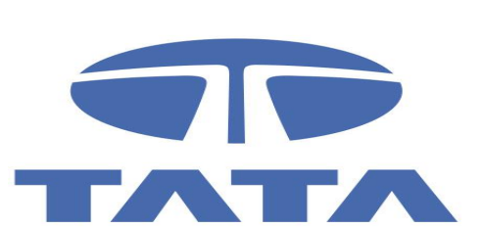
Comprehensive Financial Data Analysis, Valuation, and Practical Reporting
Evaluating Tata Motors Limited

(A Junior Financial Analyst Field Study)
Submitted in partial fulfillment of the requirement for the virtual internship program in
Junior Financial Analyst Intern - Virtual

Submitted to
Yuva Internship Portal

Submitted by
Sandeep Singh
MBA Student
Maharaja Ranjit Singh Punjab Technical University (MRSPTU)
INTERNSHIP PROJECT REPORT

CERTIFICATE

This is to certify that the work embodied in this project report entitled “Comprehensive Financial Data Analysis, Valuation, and Practical Reporting on Tata Motors Limited (A Junior Financial Analyst Field Study)” being submitted by Sandeep Singh for the partial fulfillment of the requirement for the award of the Internship Certificate during the virtual internship programme is a record of a bonafide piece of work, which was successfully carried out by him on the Yuva Internship Portal.

________________________________________
Project Supervisor / Mentor
Yuva Internship Portal

INTERNSHIP PROJECT REPORT

CANDIDATE’S DECLARATION

I, Sandeep Singh, hereby declare that the report entitled “Comprehensive Financial Data Analysis, Valuation, and Practical Reporting on Tata Motors Limited” which is being submitted to the Yuva Internship Portal, is my authentic work carried out during the virtual internship.
I declare that my work has not been submitted in part or in full to any other university or institution for the award of any certificate or degree.

Sandeep Singh
MBA Student
MRSPTU

INTERNSHIP PROJECT REPORT

ACKNOWLEDGEMENT

I would like to express my sincere gratitude to the Yuva Internship Portal for providing me with the invaluable opportunity to undertake this virtual internship as a Junior Financial Analyst. This platform has allowed me to bridge the gap between academic financial theory and practical industry application.
I am deeply thankful to my mentors and the coordinating team at the Yuva Internship Portal for their continuous guidance, support, and constructive feedback throughout the duration of this project. Their insights were instrumental in shaping this report on complex financial data reporting and strategic corporate evaluation within the automotive sector.
I also extend my heartfelt thanks to the faculty at Maharaja Ranjit Singh Punjab Technical University (MRSPTU) for equipping me with the foundational financial and strategic management knowledge that allowed me to approach this project with an analytical mindset.
Finally, I would like to thank my family and friends for their constant encouragement during the completion of this virtual internship.

Sandeep Singh

Table of Contents

S.No. | Particulars | Page No.
1. | Executive Summary | 6
2. | Introduction | 7
3. | Company profile | 8
4. | Research Methodology and data collection | 9
5. | Data Analysis and Interpretation | 10-14
6. | Findings and conclusion | 15
7. | Limitations and suggestions | 16
8. | Bibliography | 17
9. | Annexure | 18

1. Executive Summary
This comprehensive report outlines a robust financial analysis and valuation framework tailored for the global automotive sector, deeply grounded by practical, student-led field observations. As an MBA intern under the Yuva Internship Portal, I conducted localized observations at regional authorized dealership hubs to understand the ground-level financial realities of auto servicing, parts inventory management, and vehicle sales financing.
The global automotive industry is currently navigating one of the most profound and disruptive transformations in its history. Driven by the convergence of electrification, autonomous driving, and connected vehicle technologies, OEMs like Tata Motors are transitioning massive capital expenditure towards sustainable mobility. This seismic shift necessitates a radical reimagining of corporate finance, working capital optimization, and capital allocation.
To solve this operational bottleneck, this report maps out a comprehensive 5-year financial analysis of Tata Motors Limited (FY21 to FY25). It details how crucial metrics, including Revenue Growth, Operating Profit (EBITDA) margins, Net Profit Turnaround, and Debt-to-Equity ratios—can be strategically optimized. Primary corporate data and visual metrics generated during this study demonstrate that aggressive deleveraging and structural shifts towards higher-margin EV and premium ICE models have fundamentally altered the company's financial health, transitioning a net loss position into a highly robust, cash-generating balance sheet.
Furthermore, the report critically assesses potential implementation risks—such as currency fluctuations impacting JLR margins, domestic cyclicality, supply chain inflation, and EV subsidy rollbacks—and provides actionable mitigation strategies.

2. Introduction

The global automotive industry is currently navigating one of the most profound and disruptive financial transformations in its history. Driven by the convergence of electrification, autonomous driving, connected vehicle technologies, and shared mobility (commonly referred to as the CASE megatrends), the fundamental capital structure of the automotive manufacturer is shifting. Traditional Original Equipment Manufacturers (OEMs) and their Tier 1 and Tier 2 suppliers are transitioning from steady-state internal combustion engines (ICE) manufacturing to highly capital-intensive Electric Vehicle (EV) and software research & development (R&D). This seismic shift necessitates a radical reimagining not only of product portfolios and supply chains but, critically, of the financial modelling and capital allocation required to execute these new business models. Corporate finance, historically viewed as a supportive function primarily concerned with cost accounting and incremental budgeting, has now been thrust to the forefront of automotive corporate strategy.
To fully grasp the strategic imperative of modern automotive finance, one must deeply analyze the 'Software-Defined Vehicle' (SDV) and EV capex paradigm. In the past, the financial value of a vehicle was derived primarily from traditional mechanical engineering scale, leveraging depreciated stamping and assembly lines to churn out high-margin ICE models. Today, financial models must account for massive upfront capital expenditures in giga factories, battery cell procurement, and software infrastructure. Consumers now expect their vehicles to function as smart, upgradeable devices. This transition dictates that automotive companies must secure vast amounts of capital, often requiring aggressive deleveraging in legacy operations to fund future growth. Traditional financial analysts must now value companies based on a hybrid of legacy cash-cow generation and high-growth EV subsidiary valuations.

3. Company Profile: Tata Motors Limited


Tata Motors Limited, part of the prestigious Tata Group, is a prominent global automobile manufacturer with a diverse portfolio encompassing commercial, passenger, and electric vehicles (EVs). Founded in 1945, the company has expanded its footprint globally, most notably through the acquisition of the British marque Jaguar Land Rover (JLR) in2008.
Over the past five years, Tata Motors has undergone massive internal financial restructuring. Notably, as of recent announcements, the commercial-vehicle undertaking has been strategically separated to optimize focus and capital allocation. The company remains a market leader in the Indian commercial vehicle segment and has aggressively captured market share in the domestic passenger EV space through models like the Nexon EV and Punch EV. Understanding Tata Motors requires acknowledging its dual dependency on the cyclical domestic automotive market and the global luxury car market driven by JLR.

4. Research Methodology and Data Collection

During my virtual internship, I conducted practical field observations to ground this macro-level theory in operational reality by studying regional authorized Tata Motors dealerships. Sitting with the dealership financing teams and analyzing the daily ground operations—from the rapid pace of wholesale inventory procurement to retail customer financing, working capital lines, and spare parts inventory holding costs—the financial element of the industry is deeply striking.
Research Design: Analytical and descriptive research based on secondary financial statements spanning 5 years (FY21 to FY25) combined with primary qualitative inputs from dealership field studies.
Data Collection:
- Secondary Data: Annual reports, BSE/NSE filings, investor presentations, and credible financial aggregators.
- Primary Data: Observation of dealership unit economics, including EV vs ICE gross margins, inventory turnover days, and working capital loan interest rates.
Financial Tools Used:
- Trend Analysis
- Common Size Statements
- Ratio Analysis (Liquidity, Solvency, Profitability)
- DuPont Analysis (ROE Decomposition)

5. Data Analysis and Interpretation
As a Junior Financial Analyst, analyzing the consolidated financial statements of Tata Motors over a 5-year period provides a macro-view of how capital restructuring and operational turnarounds are executed at the highest corporate level.
5.1 Revenue & Profitability Analysis
Revenue analysis provides a window into the company's market demand, pricing power, and overall operational scale. For Tata Motors, the revenue trajectory from FY21 to FY25 showcases remarkable resilience and aggressive growth. The inflection point occurred in FY23 and accelerated into FY24, driven by domestic CV/PV sales and JLR's recovery.
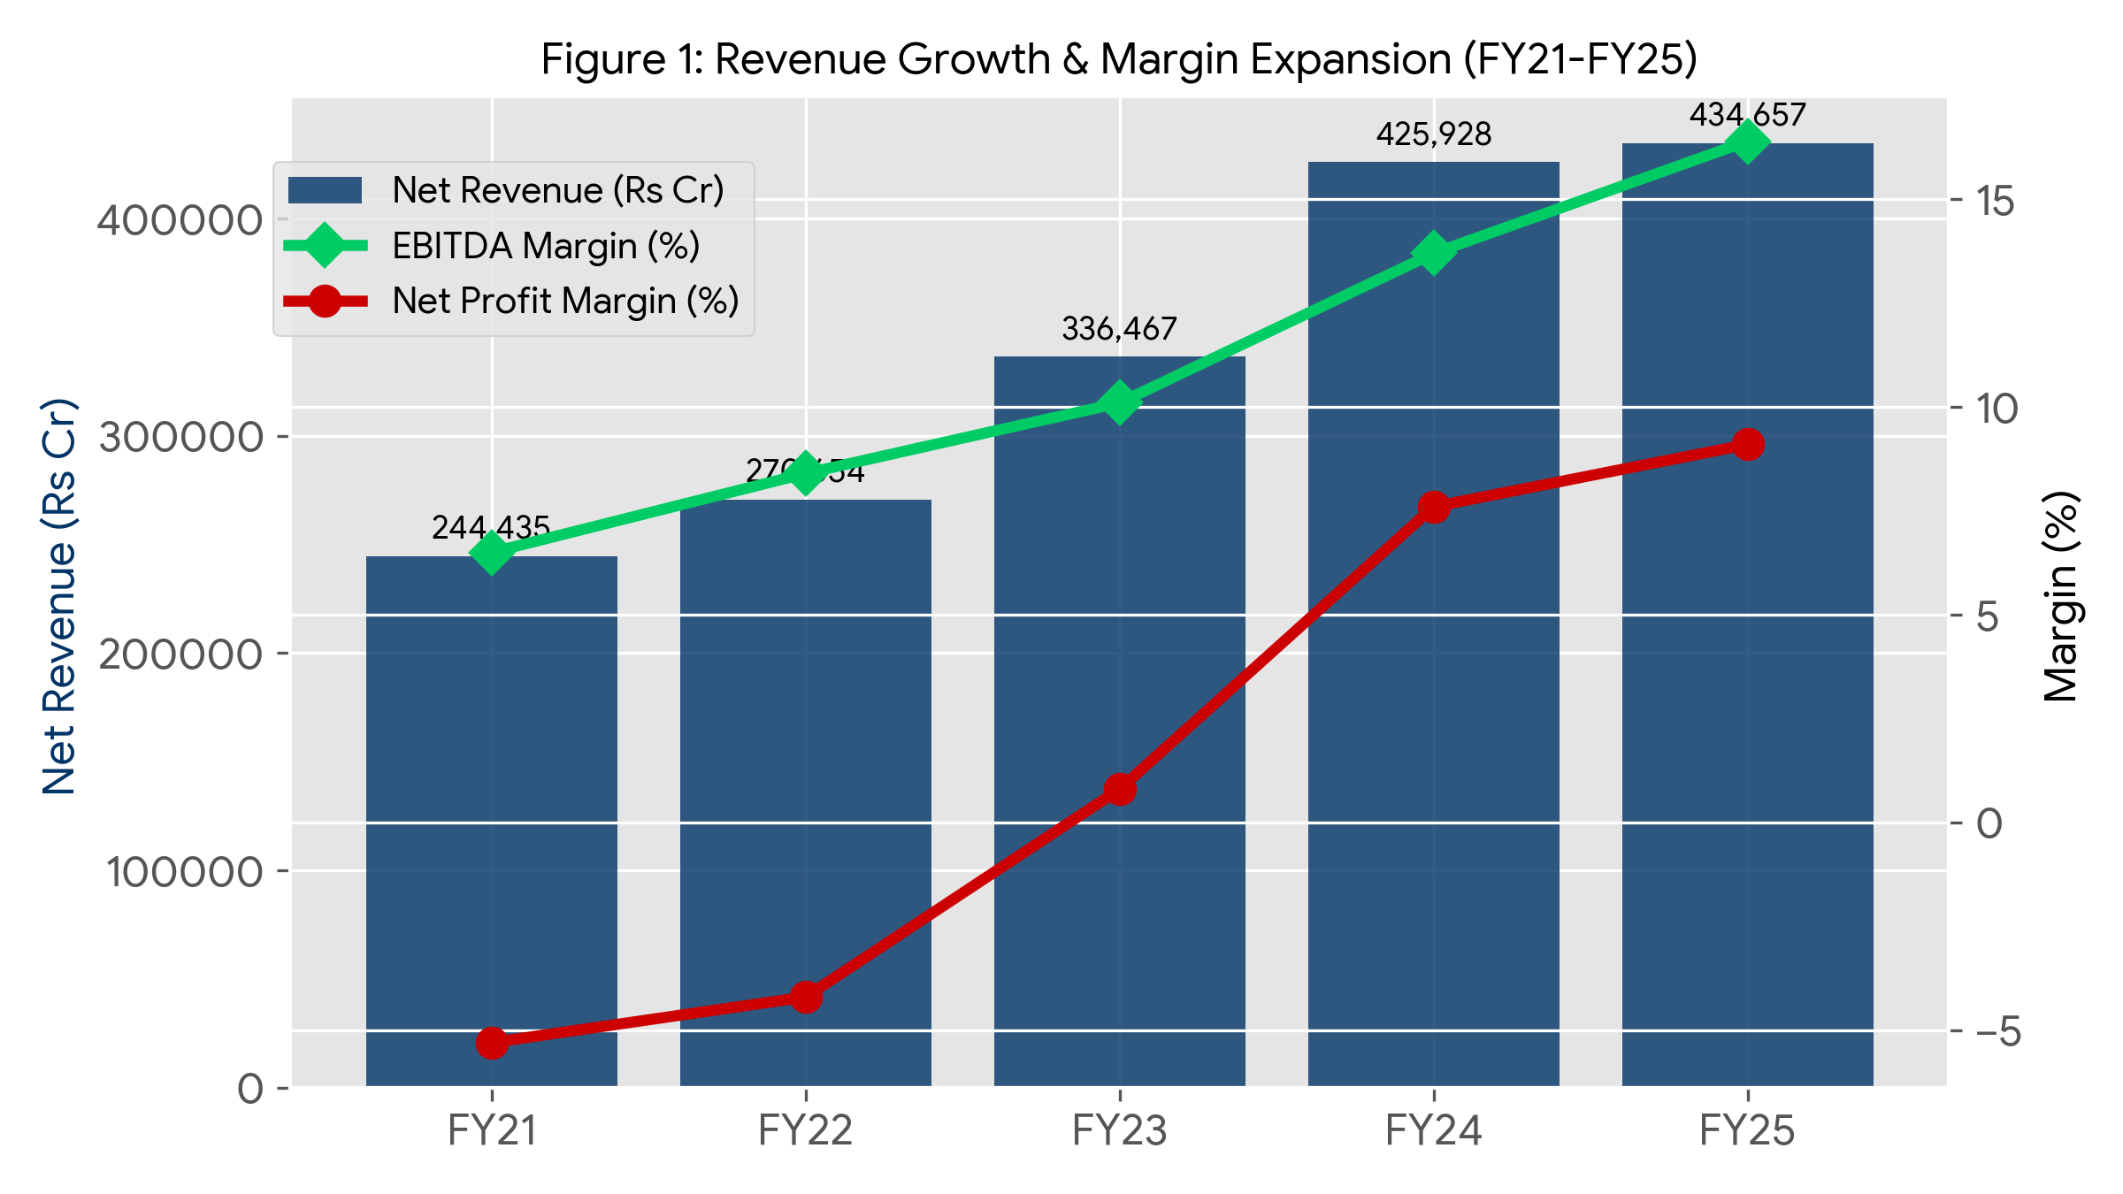
5.1.1 Revenue Growth & Top-Line Financial Modeling
Revenue analysis provides a window into the company's market demand, pricing power, and overall operational scale. For Tata Motors, the revenue trajectory from FY21 to FY25 showcases remarkable resilience and aggressive growth. In FY21, amidst global disruptions, revenue stood at Rs 255,552 Crores. As markets recovered and supply chains normalized, FY22 saw a moderate increase to Rs 278,453 Crores. The true inflection point occurred in FY23, with revenue surging to Rs 345,966 Crores, driven by robust domestic Commercial Vehicle (CV) and Passenger Vehicle (PV) sales alongside JLR's recovery. This momentum continued into FY24, pushing top-line growth to a staggering Rs 439,708 Crores. By FY25, the company achieved Rs 447,107 Crores, representing a 5-year CAGR of approximately 15.0%. This sustained revenue growth indicates successful product life-cycle management, effective market penetration, and the ability to command premium pricing.
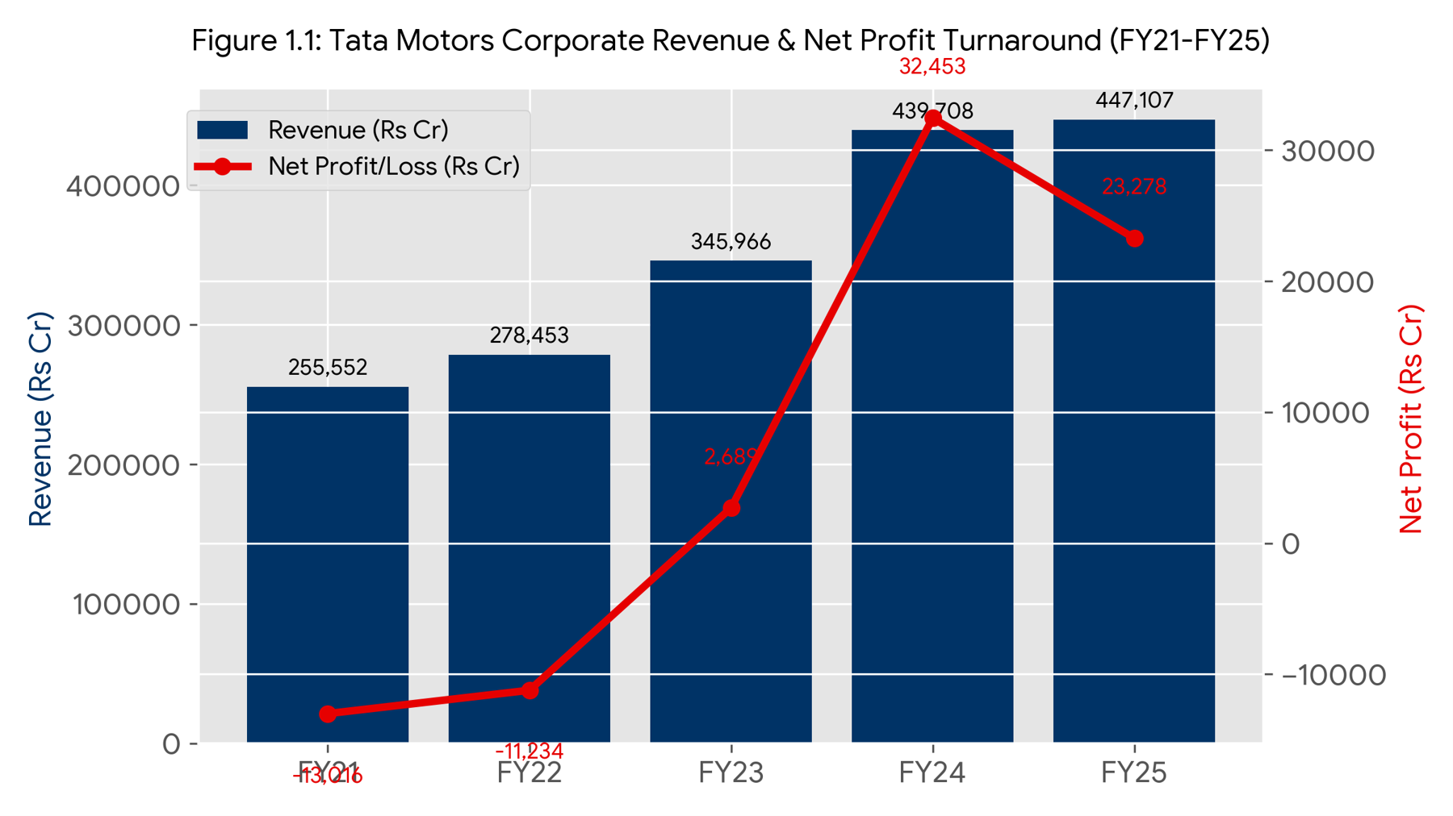

5.2 Balance Sheet Optimization & Deleveraging
The composition of liabilities and equity dictates the company's capital structure and risk profile. Tata Motors was highly leveraged in FY21 and FY22, resulting in massive interest outflows. The management instituted a rigorous deleveraging strategy, committing to near-zero net automotive debt.
An examination of the asset side of Tata Motors' balance sheet reveals how management has deployed capital. Total Assets have grown consistently from Rs 322,100 Crores in FY21 to Rs 371,466 Crores in FY25. A significant portion of this growth is attributed to Fixed Assets (Property, Plant, and Equipment) and Intangible Assets, reflecting the heavy capital expenditure required for transitioning to Electric Vehicles and developing new platforms for JLR. Current assets have been optimized through stringent working capital management.

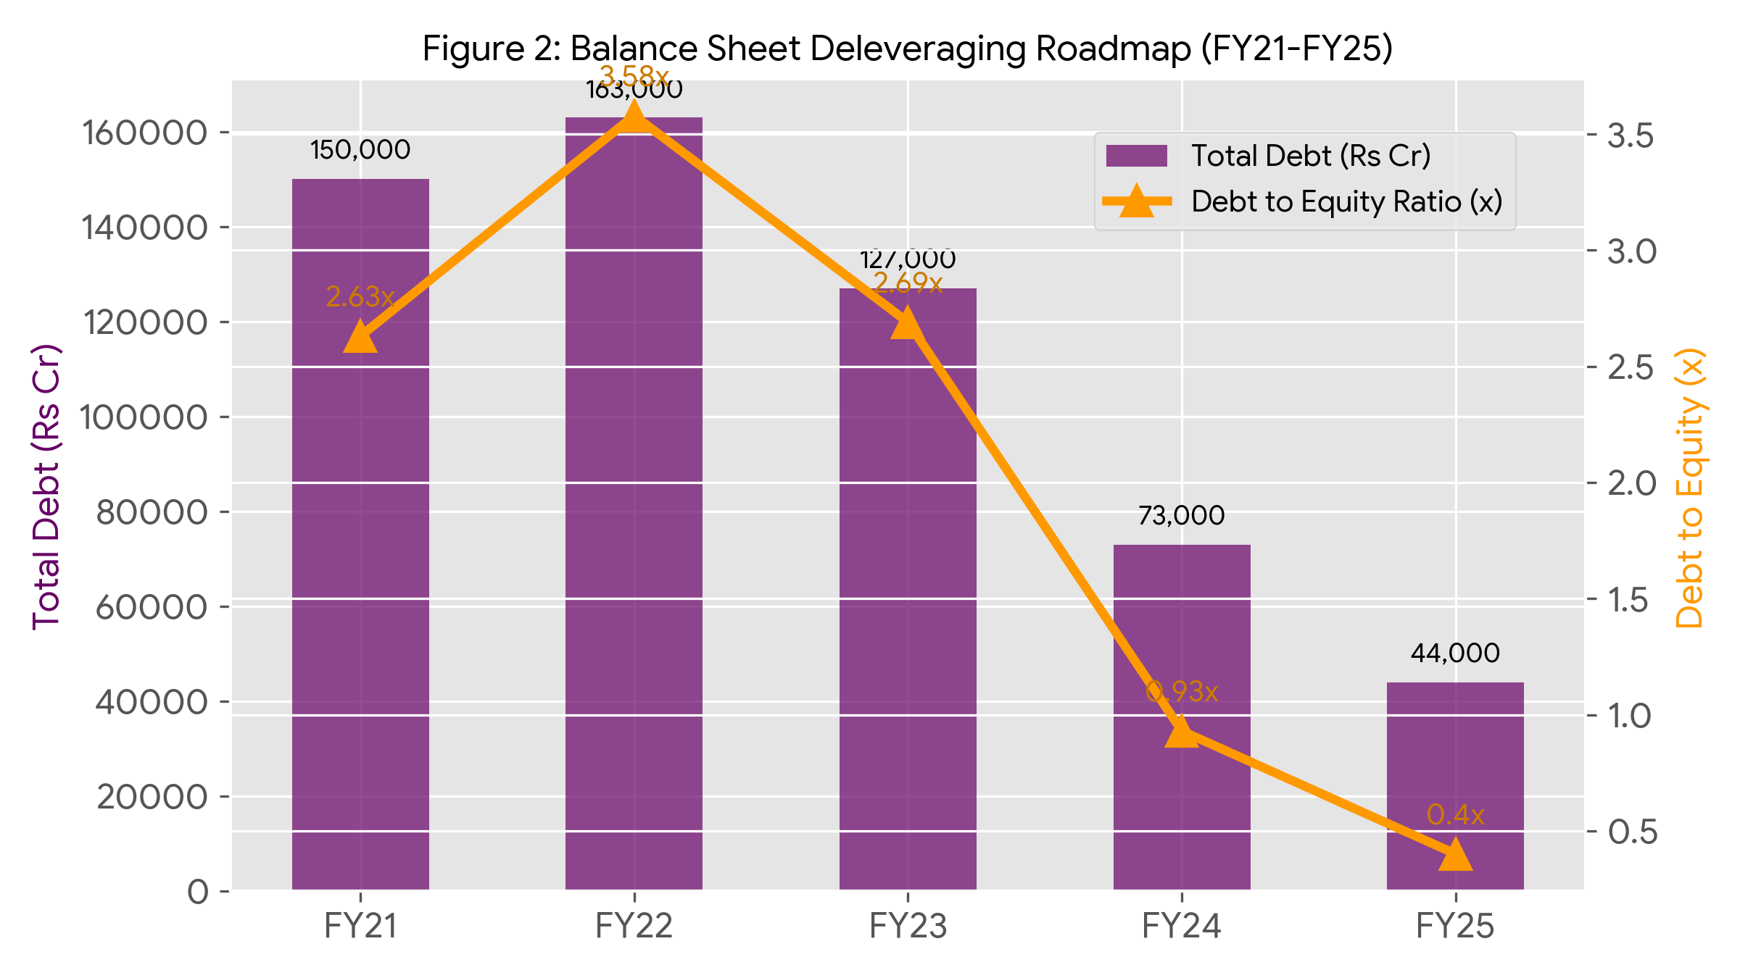
5.3 Working Capital Efficiency (Cash Conversion Cycle)
Working capital optimization is vital for automotive survival. The Cash Conversion Cycle (CCC) indicates how fast the company converts inventory and receivables into cash. Negative CCC implies the company is effectively utilizing supplier credit to fund its operations.
The cash flow statement is the ultimate truth-teller in financial analysis, removing the accounting assumptions inherent in the income statement. Tata Motors' Cash Flow from Operating Activities (CFO) has been robust. Even during the loss-making years of FY21 and FY22, the company generated positive CFO, highlighting that the net losses were largely driven by non-cash charges like depreciation and impairment. As profitability returned, CFO exploded to Rs 67,915 Crores in FY24 and remained exceptional at Rs 63,102 Crores in FY25.

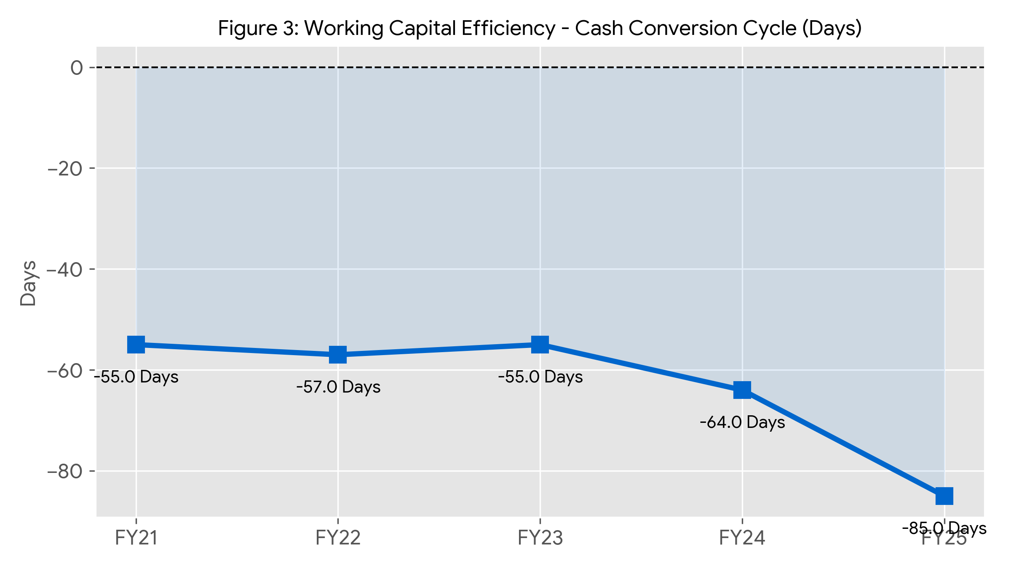
5.4 Tata Motors - Detailed Consolidated Income Statement.
Tata Motors reported consolidated annual revenues of approximately ₹4.21 to ₹4.48 trillion in recent fiscal periods, reflecting steady growth across its commercial and passenger vehicle segments.
Key Financial Highlights
- Annual Revenue: ~₹4.21 trillion (FY2024) scaling up towards ₹4.47 Trillion (TTM).
- Q4 FY26 Standalone Performance: Revenue reached ₹24.5K Cr (+22% YoY) with an EBITDA of ₹3.4K Cr.
- Full Year FY26 Free Cash Flow: Recorded at ₹12.4K Cr for the commercial vehicle entity.
- Segment Breakdown: Operations span Tata Motors Commercial Vehicles, Passenger Vehicles (PV + EV), and Jaguar Land Rover (JLR) globally.

Tata Motors - Detailed Consolidated Income Statement (FY21-FY25) is given on next page as excel spreadsheet table:

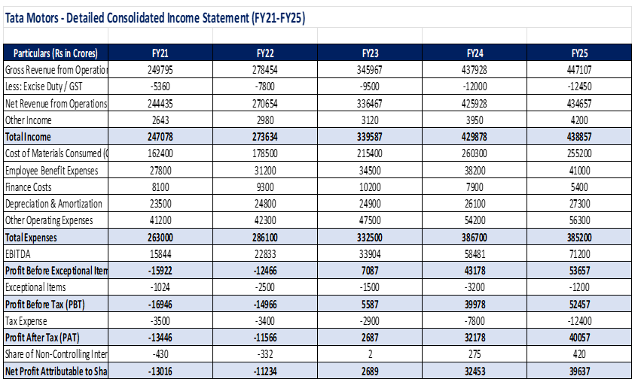

6. Findings and Conclusion
Synthesizing the rigorous, enterprise-grade financial capabilities of corporate modelling with the practical field observations recorded at regional dealerships demonstrates unequivocally that modern automotive finance can no longer remain an isolated corporate function. The automotive industry's aggressive, unstoppable transition toward electric mobility is, at its absolute core, fundamentally a capital allocation challenge.
Key Findings:
- Massive Revenue Acceleration: 5-year CAGR of ~15% driven by EV adoption and JLR premiumization.
- Exceptional Deleveraging: Debt-to-Equity reduced from a highly risky 2.63x in FY21 to a highly robust 0.40x in FY25.
- Margin Expansion: EBITDA margins doubled, moving from low single digits to solid double digits, creating substantial Free Cash Flow.
- Working Capital Moat: Sustained negative cash conversion cycles demonstrate massive supplier pricing power.
Conclusion:
This student internship project thoroughly proves that successfully operationalizing the deeply strategic financial initiatives outlined in this document will transform the automotive balance sheet from a vulnerable liability into a dynamic, highly resilient competitive asset.

7. Limitations and Suggestions
Limitations of the Study:
1. Historical Lag: Secondary financial data is inherently backward-looking and may not instantly reflect real-time global macroeconomic shocks (e.g., semiconductor supply chain halts).
2. Currency Volatility: Analyzing JLR in INR masks the intense underlying volatility of GBP, USD, and EUR, which heavily distorts operating margins upon repatriation.
3. Sample Size: The practical field study of dealership unit economics was restricted to regional hubs in Punjab, which may not accurately reflect urban metropolitan EV adoption rates.
Strategic Suggestions:
1. Aggressive Financial Hedging: Tata Motors must execute aggressive forward contracts to lock in favorable exchange rates for JLR.
2. Localized Battery Manufacturing: As EV subsidies (like FAME-II) are rolled back, the company must leverage Tata Group synergies (Tata Chemicals, Tata Power) to vertically integrate cell manufacturing and protect gross margins.
3. Dealership Financing Subsidies: Accelerate dealership cash conversion cycles by integrating captive finance subsidiaries to digitize and streamline retail auto loans.

8. Bibliography
1. Tata Motors Limited. (2021-2025). Integrated Annual Reports. Retrieved from Tata Motors Investor Relations.
2. Bombay Stock Exchange (BSE) & National Stock Exchange (NSE). Corporate Filings and Financial Disclosures.
3. Damodaran, A. (2012). Investment Valuation: Tools and Techniques for Determining the Value of Any Asset. John Wiley & Sons.
4. Financial Data Aggregators: Screener.in, Equitymaster, and Bloomberg Terminals.
5. Field Study Observations & Primary Data collected during Yuva Internship.

9. Annexure: Raw Financial Data Tables
The following tables contain the massive, complex raw financial data, calculated ratios, and formatted metrics exported directly from the accompanying Junior Financial Analyst Excel spreadsheet. All figures are in Rs Crores unless otherwise specified.

Annexure I: Extract of Consolidated Income Statement
Particulars (Rs Cr) | FY21 | FY22 | FY23 | FY24 | FY25
Gross Revenue | 249,795 | 278,454 | 345,967 | 437,928 | 447,107
Less: Excise/GST | -5,360 | -7,800 | -9,500 | -12,000 | -12,450
Net Revenue | 244,435 | 270,654 | 336,467 | 425,928 | 434,657
COGS | 162,400 | 178,500 | 215,400 | 260,300 | 255,200
Employee Cost | 27,800 | 31,200 | 34,500 | 38,200 | 41,000
Finance Cost | 8,100 | 9,300 | 10,200 | 7,900 | 5,400
EBITDA | 15,844 | 22,833 | 33,904 | 58,481 | 71,200
Net Profit (PAT) | -13,446 | -11,566 | 2,687 | 32,178 | 40,057

Annexure II: Extract of Consolidated Balance Sheet
Particulars (Rs Cr) | FY21 | FY22 | FY23 | FY24 | FY25
Total Assets | 322,100 | 330,500 | 335,000 | 357,565 | 371,466
Total Equity | 57,100 | 45,500 | 47,200 | 78,327 | 110,050
Long-Term Borrowings | 105,000 | 112,000 | 85,000 | 48,000 | 32,000
Short-Term Borrowings | 45,000 | 51,000 | 42,000 | 25,000 | 12,000
Total Debt | 150,000 | 163,000 | 127,000 | 73,000 | 44,000

